White phosphorus burn: A clinical report by Palestinian physicians

AUTHOR: Loai Nabil Al Barqouni, Sobhi I Skaik, Nafiz R Abu Shaban, Nabil Barqouni

In January, 2009, an 18-year-old man presented to the emergency department after suffering an attack with an incendiary shell. He had many painful patches of full-thickness burns, which were surrounded by sloughed tissue. His wounds covered 30% of his body surface area, and were distributed on both upper and lower limbs, and his right shoulder. There were no signs of inhalation burns. After a clinical diagnosis of white phosphorus burns was made, the airway was secured, resuscitation fluid was initiated, and wounds were irrigated with diluted sodium bicarbonate solution before wet dressing.
1 day after admission to the burns unit, white smoke was noticed emanating from the wounds, which now contained extensive necrotic tissue and had extended into the underlying tissue (figure A and B). He was urgently transferred to the operating room for debridement and excision of necrotic tissue, and removal of white phosphorus particles. During debridement, a white phosphorus particle was accidentally dislodged resulting in a superficial burn on a nurse's neck. We transferred our patient to the intensive care unit for monitoring of vital signs, electrolyte disturbance (in particular hypocalcaemia), and electrocardiogram (ECG) changes. After 8 days in hospital, our patient was relatively well, and was discharged without any systemic complications. At 16-month follow-up, our patient was well; however, hypertrophic, mildly tender scars remained on his chest, arm, and thigh (figure C and D).

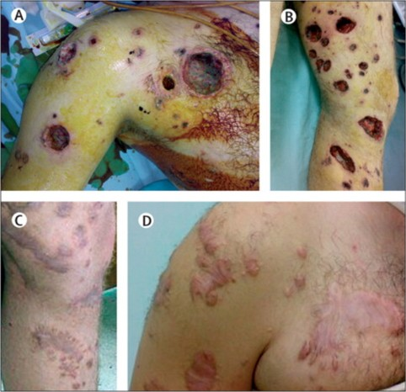
White phosphorus burn
Many lesions, with severe underlying destruction and necrosis in the right shoulder (A) and left leg (B). After 16 months of follow-up (C, D).
White phosphorus is a smoke-producing, waxy, yellow transparent combustible solid,1 which is used mainly in military and industrial settings. In the presence of oxygen, it spontaneously ignites with a yellow flame and produces dense smoke; it extinguishes only when deprived of oxygen or totally consumed.2 On contact with exposed skin, white phosphorus produces painful chemical burns;3 these typically appear as yellowish, necrotic, full-thickness lesions due to both chemical and thermal components.
Because white phosphorus has high lipid solubility, the injuries often extend deep into underlying tissues with resultant delayed wound healing. White phosphorus can also be absorbed systemically resulting in multiple organ dysfunction syndrome because of its effect on erythrocytes, kidneys, liver, and heart.2, 4 First aid management of white phosphorus burns includes removal of the patient's clothes and application of saline or a water-soaked dressing.1
On the basis of animal studies and case reports, in the emergency department, continuous irrigation with water is recommended to minimise the complications of the burn,1, 2, 4 and large easily identifiable particles of white phosphorus should be debrided. Wood lamp (ultraviolet light) or a solution of 0�5% copper sulphate can be used to facilitate the extinction of embedded particles.4
In critically ill patients, excision of the necrotic tissue and skin grafting, plus appropriate fluid replacement, and close monitoring of electrolytes and ECG are required to avoid predictable complications like hypocalcaemia, hyperphosphataemia, and cardiac arrhythmia.
White phosphorus burns are associated with significant morbidity often necessitating lengthy hospital stays. Extreme cases can be fatal.
We cannot give an estimate of the number of such cases in our burns unit because it is in a war situation in which no formal recording was done; these burns are rarely encountered in practice and literature describing cases is limited. According to the UN Convention on Certain Conventional Weapons it is prohibited to make civilians the object of attack by incendiary weapons.
Contributors
Patient management: NS, SS, LB; writing the report: LB, NB. Written consent to publish was obtained.
References
1 Lisandro I. CBRNE�incendiary agents, white phosphorus.http://emedicine.medscape.com/article/833585-overview. (accessed May 21, 2010).
2 Eldad A, Simon GA. The phosphorous burn�a preliminary comparative experimental study of various forms of treatment. Burns 1991; 17: 198-200. CrossRef | PubMed
3 Chou TD, Lee TW, Chen SL, et al. The management of white phosphorus burns. Burns 2001; 27: 492-497. CrossRef | PubMed
4 Davis KG. Acute management of white phosphorus burn. Mil Med 2002; 167: 83-84. PubMed
The authors
Loai Nabil Al Barqouni: Faculty of Medicine, Al Quds University, Abu-Deis, Jerusalem, 00970 occupied Palestinian territory
Sobhi I Skaik FRCSEd: Department of Surgery, Shifa Medical Centre, Gaza Strip, occupied Palestinian territory
Nafiz R Abu Shaban MSc: Department of Plastic Surgery and Burns, Shifa Medical Centre, Gaza Strip, occupied Palestinian territory
Nabil Barqouni CABP: Al Nasser Pediatric Hospital, Gaza Strip, occupied Palestinian territory
Correspondence to: Loai Nabil Al Barqouni, Faculty of Medicine, Al Quds University, Abu-Deis, Jerusalem, 00970 occupied Palestinian territory

Source: White phosphorus burn (THE LANCET)
Original article published on July 3, 2010.
http://www.tlaxcala.es

